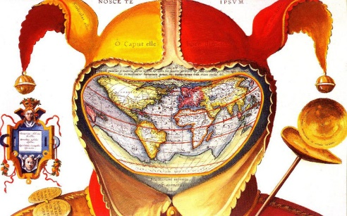
Exploration and Explorer Project
Objective-
Part1: Students will write a research based essay describing the causes/effects and results of one country’s world exploration.
Part2: Students will work in small groups to research their assigned country’s exploration and complete information about the explorer’s intentions and results. They will complete a world map of their country’s routes, provide information and facts to display, and complete a timeline of exploration.
Materials-
- Social Studies textbook
- Explorers book
- Copied resource materials
Research based essay requirements:
- 5 paragraphs
- Introduction including the country name and basic fact about the exploration.
- Main paragraph 1 – Why explore? What was the motivation?
- Main paragraph 2 – Who were the explorers and what were they looking for?
- Main paragraph 3 – What were the results of this exploration? What changes were made in the world?
- Conclusion – Sum it up.
Group work:
- Map the explorer’s routes and label their names on routes.
- Complete graphic organizer.
- Complete timeline of exploration.
- Information about your country’s exploration.
- Short biography on 3-4 explorers of your country.

