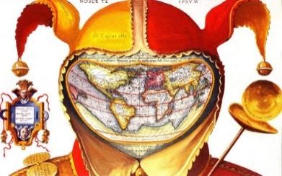
Explorer Short Biography

______________________________________________________________________________________________________________________________________________________________________________________________________________________________________________________________________________________________________________________________________________________________________________________________________________________________________________________________________________________________________________________________________________________________________________________________________________________________________________________________________________________________________________________________________________________________________________________________________________________________________________________________________________________________________________________________________________________________________________________________________________________________________________________________________________________________________________________

